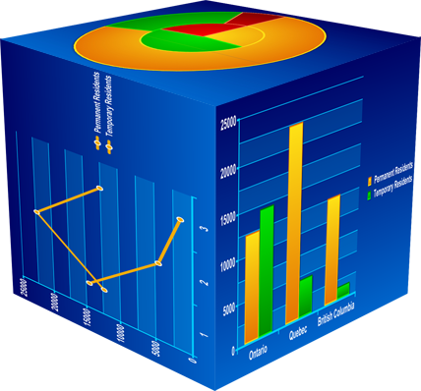
Research Datamart

Table of Contents

Main Menu Interface p.2

Main Menu Buttons p.3

Opening a Microsoft Excel or Word Document p.3

Excel Pivot Table - Enabling Content p.4

Excel Pivot Table – Data Connectivity p.5

Excel Pivot Table Instructions p.6

Introduction to pivot tables p.6

Selecting the data fields for the pivot table p.6

Working with Totals in a pivot table p.9

Saving a pivot table to your computer p.11

Main Menu Interface

The Main Menu Interface is an interactive tool which allows the user to select their desired information. Once installed, the Main Menu Interface wills pop-up automatically.
For any future use, there will be a shortcut,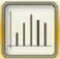, of the application on the (user’s) desktop.

The Main Menu Interface will resemble the one outlined below.

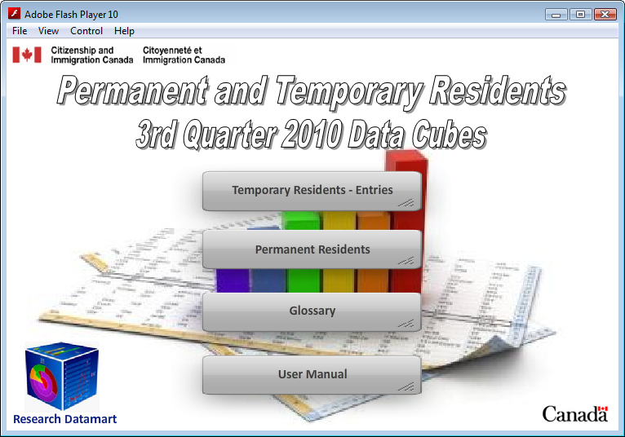
These buttons are linked to the corresponding Excel Pivot tables.
These buttons provide the user with access to documentation.

Main Menu Buttons ^{^Top}

Temporary Residents – Entries: The data examines the flow of foreign nationals who are lawfully in Canada on a temporary basis under the authority of a valid document (i.e., a work permit, study permit, temporary resident permit, or a visitor record). Temporary residents include foreign workers, foreign students, the humanitarian population and other temporary residents.

Permanent Residents: The data represents all the individuals who have been granted permanent resident status in Canada for any given year. Permanent residents must live in Canada for at least 730 days (two years) within a five-year period. Permanent residents have all the rights guaranteed under the Canadian Charter of Rights and Freedoms such as equality rights, legal rights, and mobility rights, freedom of religion, freedom of expression and freedom of association.

Glossary: This document provides in-depth explanation of all the variables and its corresponding terminology found within each excel pivot table (i.e. Temporary Residents and Permanent Residents).

Opening a Microsoft Excel or Word Document ^{^Top}

When opening an excel or word document – through the main menu buttons – a pop-up window (as illustrated below) will appear. Please note that this window may appear on your computer, depending on your settings.

If the pop-up does appear, uncheck the box where it asks “Always ask before opening this type of file” and then click on Open.
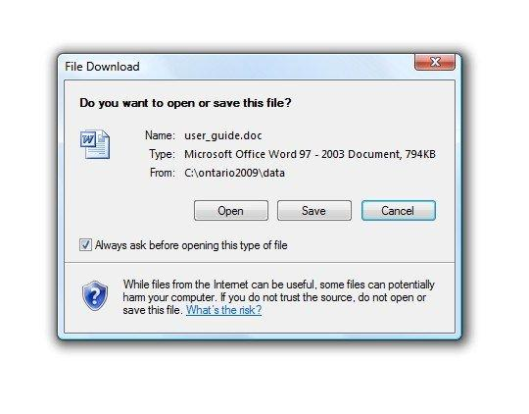
1. Uncheck this box.
2. Click Open.
Once the above steps have been executed, the Excel or Word document will open. In addition, for subsequent use, the pop-up window will no longer appear.

Excel Pivot Table - Enabling Content ^{^Top}

The Temporary Resident and Permanent Resident data cubes are Excel Pivot Tables. Therefore, when opening an Excel Pivot Table for the first time, there will be a security warning at the top left hand-side, underneath the toolbar, as outlined in the image below. The Security Warning must be enabled in order to manipulate the data cubes.

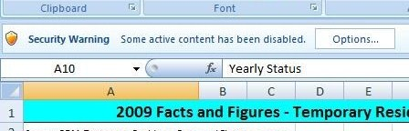
Excel Security Warning – must be enabled before manipulating the data cubes.
1. Click Options.

In order to enable the security setting, click on Options, and the following pop-up window will appear.

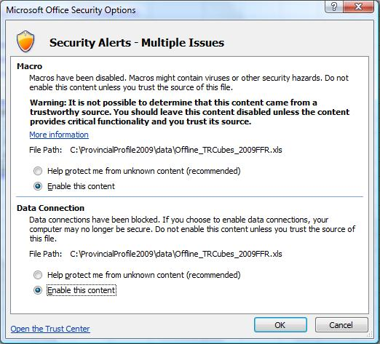
2. Click Enable this content.
3. Click Enable this content.
4. Click OK.

When the window appears, click Enable this content for the Macro and Enable this content for the Data Connection. Once both options have been selected, click OK.

These steps will need to be done only once for each corresponding Excel Pivot Table.

Excel Pivot Table – Data Connectivity ^{^Top}

Once the content within the Excel Pivot tables have been enabled - as outlined above - and an error message appears in regards to the data connectivity; please refer to the following Microsoft web-site to attain the required updates/software packages, necessary to run the Excel Pivot Tables.

http://www.microsoft.com/downloads/en/details.aspx?familyid=78cac895-efc2-4f8e-a9e0-3a1afbd5922e&displaylang=en

Excel Pivot Table Instructions

Introduction to pivot tables ^{^Top}

A pivot table is an in-built interactive function of Microsoft Excel 5.0 or higher. Data can be selected and arranged in whatever format is appropriate. Selected data fields included in the pivot table can be quickly reorganized by using the mouse. Numeric data is automatically summed in a pivot table, non numeric data is counted.

Pivot Tables allow the user to manipulate data through an array of options, such as:

- Data fields can be dragged from a list above the table or in a show fields list into the pivot table.
- Data fields can be dragged from a column and dropped into a row and vice versa.
- Data filters can be applied to the pivot table by selecting the drop-down arrows in the list of
fields.
- Totals and subtotals can be displayed or hidden.
- Data can be sorted or grouped.

Many other Excel tools and features are available to sort and format your pivot table.

You can save a pivot table to your own computer, or work with the table directly from the interactive front page. However, you will need to save your ‘finished’ pivot table to your computer if you wish to refer to it again.

The original pivot table will always remain available on the CD – do not be afraid to experiment!

Below is an illustration of a Pivot Table.
← Title
← List of Fieldnames

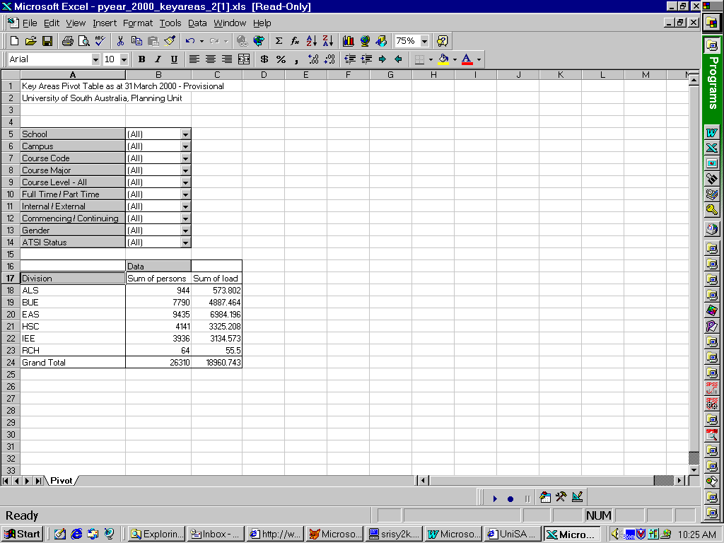
Selecting the data fields for the pivot table ^{^Top}
- Pivot Table

You will see the title, then a list of fieldnames at the top left (e.g. ‘Division’, ‘Campus’ etc.) or on the right-hand side in the field list, and a default pivot table containing the Calendar Year for the past 10 years and the Immigration or Yearly Status category. In this example, the ‘data’ in the pivot table (shown below) shows the number of student’s enrolled (sum of persons) and their total load (sum of load).

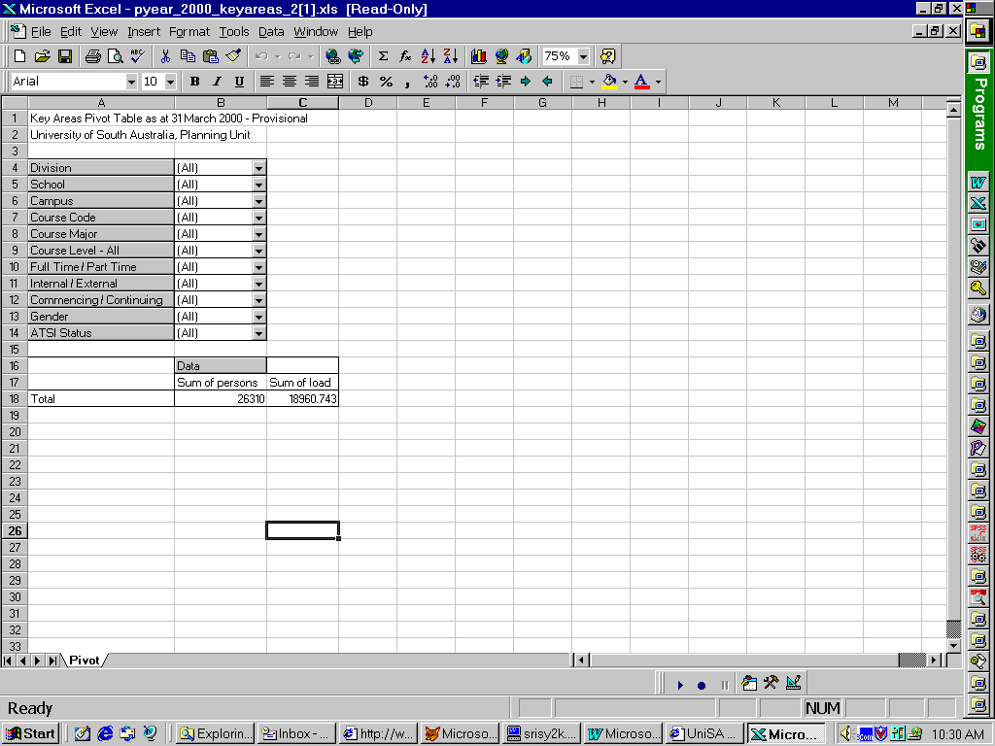
Suppose we want to see more detail in the data.

- A data field in the list of fields at the top can be moved into a new column of the table:

Suppose we want to see how many students are in each Division. Click on the fieldname ‘Division’ in the field list and holding the mouse button down, drag the mouse pointer down to the left hand side of the table until the shape of the mouse pointer changes to a ‘column’ shape (near the word ‘Total’). Release the mouse button, and the field will be dropped into the table.

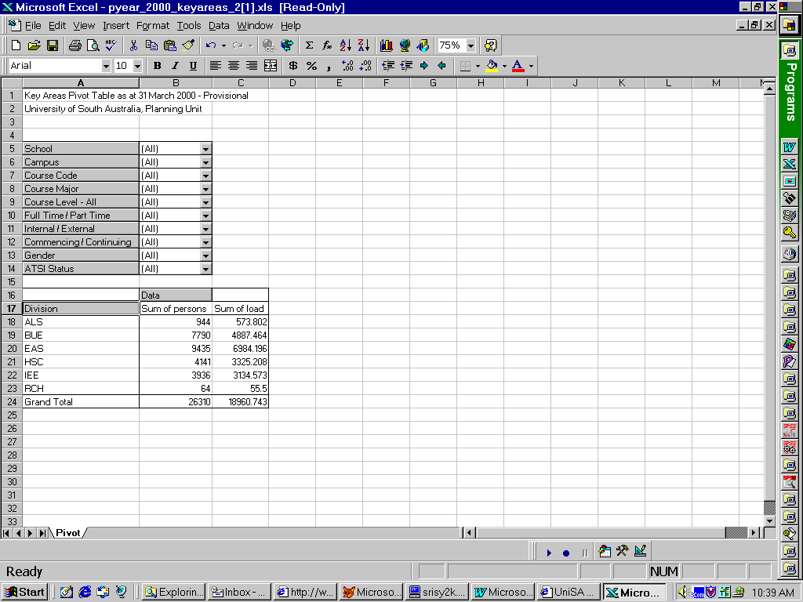
NOTE: If the mouse pointer changes to an ‘X’ shape, do not release the mouse key or the data field will be removed from the table. Too late? Don’t worry, you can get back to the original table by reopening it from your internet browser or, for more advanced users, going to the pivot table wizard – right click on the word ‘Data’ and select wizard.

NOTE: You may notice that adding a ‘column’ heading to the table actually produces new rows of data in the table. Vice versa, adding a ‘row’ heading actually produces new columns of data. You may see this alternative terminology used in the Excel as you use pivot tables more.

- Now add the data field ‘gender’ as a new row into the table:

Suppose we also want to know how many male and female students are in each Division.
Click on the fieldname ‘Gender’ in the field list and holding the mouse button down, drag the pointer down to the right hand side of the ‘Division’ column until the shape of the mouse pointer changes to a ‘row’ shape (near the word ‘Data’). Release the mouse button, and the field will be dropped into the table.
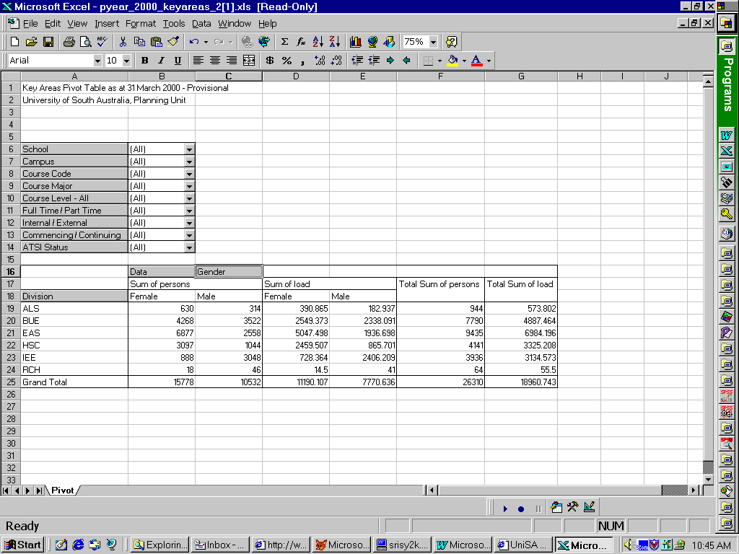

- The field ‘Gender’ could have been added as a second column in the table, instead of a row.

Move the field ‘Gender’ from a row to a column instead:

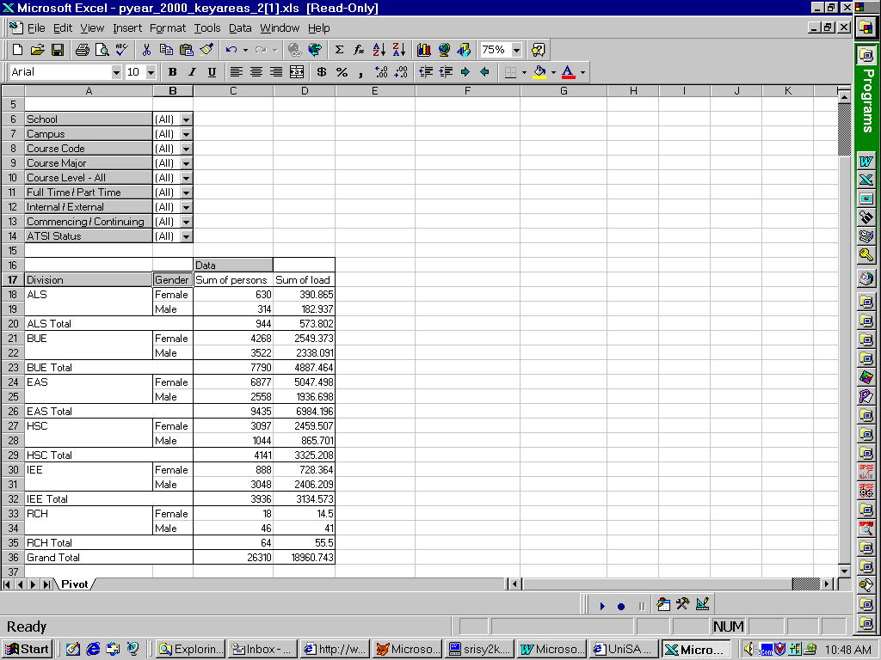
Click on the row name ‘Gender’ in the pivot table and holding the mouse button down, drag the pointer down to the left hand side near the ‘Division’ column until the shape of the mouse pointer changes to a ‘column’ shape. Release the mouse button, and the field will be dropped into the table as a column.

If you now have the column ‘Gender’ first (on the left) and ‘Division’ on the right, but would like them the other way around, try clicking on one and moving it to the other location. Watch the shape of the mouse pointer to see if you are going to make a row or a column.

We have looked at the Division and Gender data in three different formats – you can choose which one you like the best.

- A data field may be removed from the pivot table and put back into the list of fieldnames at the top of the table:

Suppose we do not want the Division data in the table any more.

Click on the column name ‘Division’ in the pivot table and holding the mouse button down, drag the mouse pointer up to the fieldname list above the table until the shape of the mouse pointer changes to a ‘list’ (or ‘steps’) shape. Release the mouse button, and the data field will be dropped back into the list of fieldnames, and removed from the pivot table.

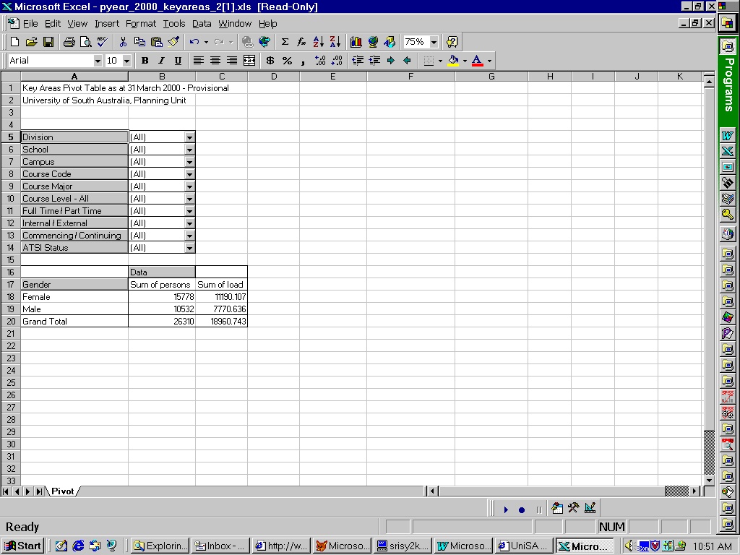
- We can apply a filter to the pivot table by using the drop-down arrows in the fieldname list.

Suppose we want to filter the data in the table to show only the students at City West campus:

Click on the drop-down arrow to the right of the fieldname ‘Campus’. Click on the words ‘City West’. Keep your eye on the pivot table data below as you do this. The data will change to only show City West numbers. To remove the filter, click on the drop-down arrow next to ‘Campus’, then click on the word ‘All’. Watch the data in the pivot table change back to include all students.

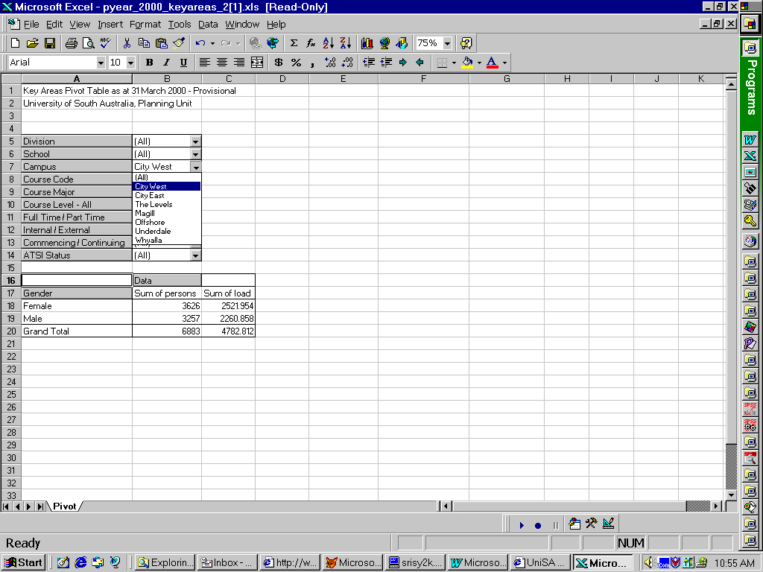

Working with Totals in a pivot table ^{^Top}

In the table below, you will see a list of fieldnames at the top left (e.g. ‘Division’, ‘Campus’ etc.), and a pivot table containing only a row of totals below. The ‘data’ in the pivot table shows the number of student’s enrolled (sum of persons) and their total load (sum of load).

Add the fields Division, Campus and Gender to the table as three columns, left to right. (See instructions Section 2 if you do not know how to do this.)

You will see that the table automatically includes subtotals for Division and Campus.

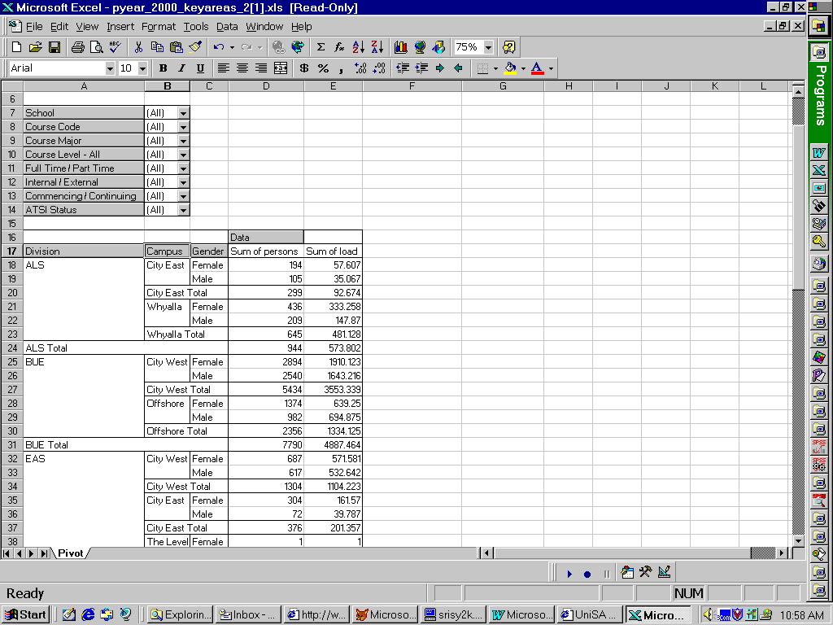
- Suppose we do NOT want to see the subtotals for ‘Campus’ in the table:

Right click on the column name ‘Campus’ in the pivot table. In the drop down menu that appears, click on ‘field’. Under the heading ‘subtotals’, click next to the word ‘none’ instead of ‘automatic’. Then click ‘OK’. The pivot table will now not have the subtotals for ‘Campus’.

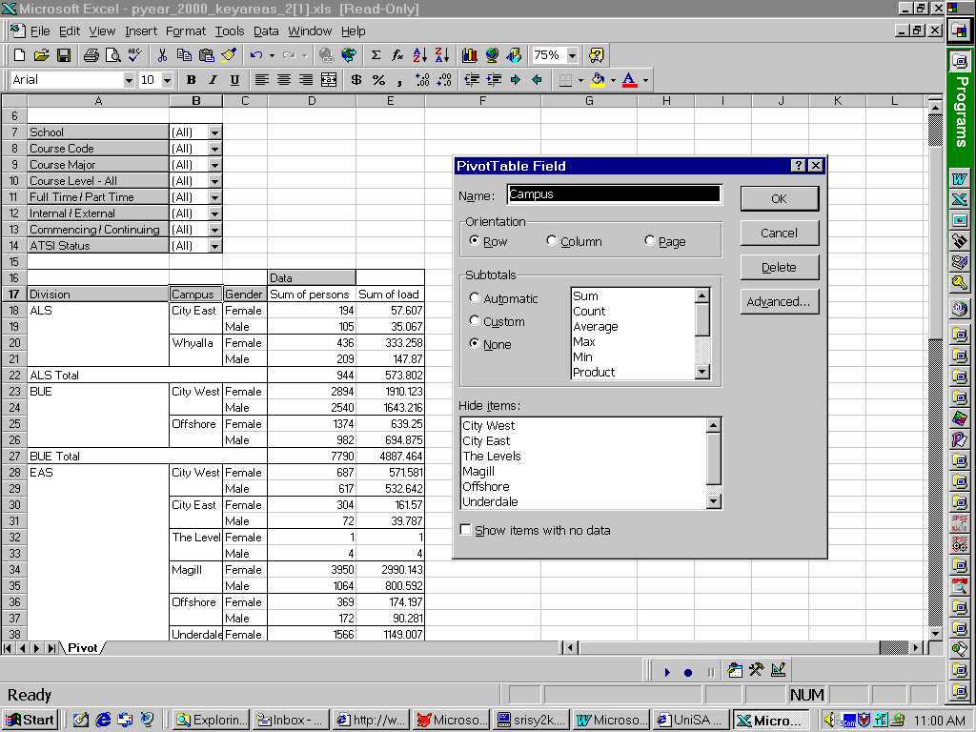
- Suppose we do NOT want to see the grand total for the table:

Right click on the word ‘Data’ in the pivot table. In the drop down menu that appears, click on ‘options’. Uncheck the box next to ‘Grand totals for columns’. Then click ‘OK’. The pivot table will now not have a grand total.

Other subtotals and grand totals can be manipulated in a similar way.

Saving a pivot table to your computer ^{^Top}

You can work with the original pivot table on the CD, but if you want to keep a pivot table the way you have formatted it, you need to save a copy of it to your computer.

- Saving the table as a pivot table.

Using this method, you will save the pivot table as it appears, and have a copy of the pivot table which can still be manipulated as if it were the original pivot table! This will take up more room on your computer than the second method below, but is more versatile.

From the Excel toolbar at the top of the pivot table click on ‘File’, then click on ‘Save as’.
Select a folder on your computer where you wish to save the table. Change the file name if you wish, then click ‘Save’.

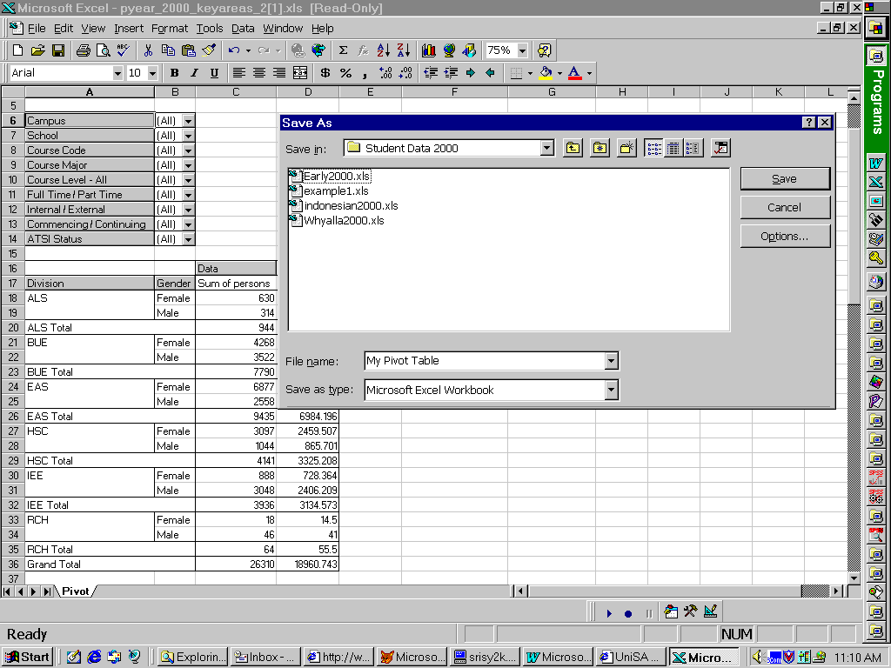
You will now have a copy of the pivot table on your computer.

- Saving the table as data only.

Using this method, you will save the table data as it appears, and have a copy of the data only which can NOT be manipulated as a pivot table. This is useful if you wish to send the data to a third party, or want to keep the formatted table for future use. It takes up less space on your computer than keeping the whole pivot table.

Select the rows of the table you wish to keep. Click and drag down the row numbers on the left of the table (the rows selected will be colored black.)
Click on ‘Edit’, then click on ‘Copy’.

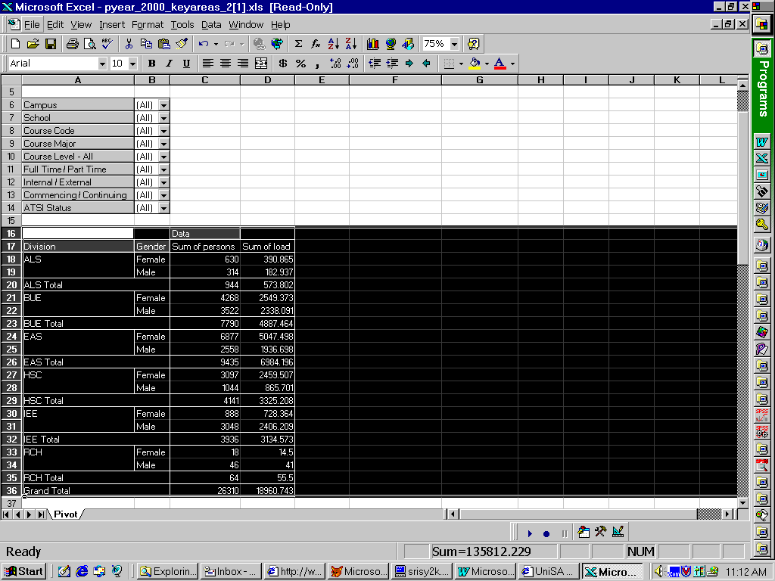
Open a new Excel file to copy the table into. Click on ‘File’, then click on ‘New’.
Paste the table into the new file. Click on ‘Edit’, then click on ‘Paste’.

Now save the new file on your computer.
From the Excel toolbar at the top of the pivot table click on ‘File’, then click on ‘Save as’.
Navigate to a folder on your computer where you wish to save the table. Change the file name if you wish, then click ‘Save’.
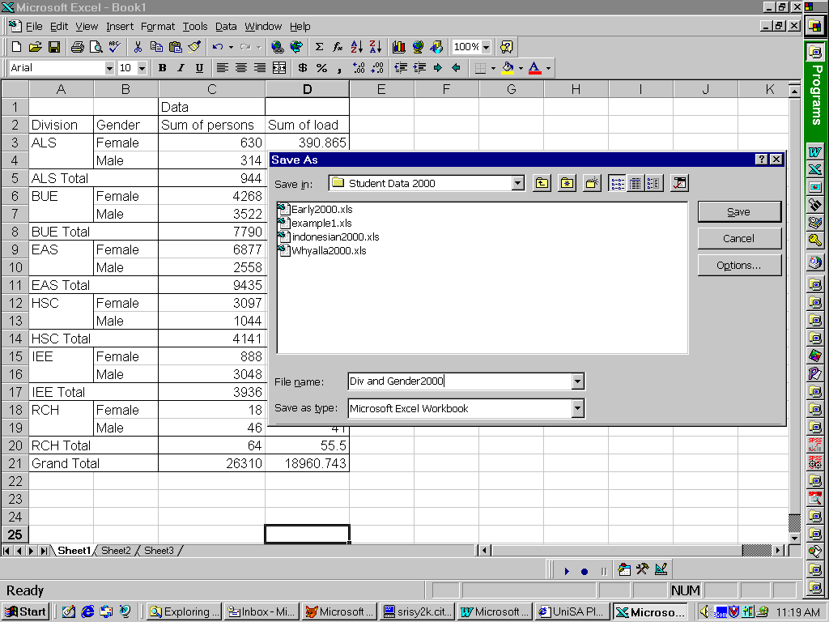
You will now have a copy of the table on your computer as an Excel file, but not a pivot table.

